Overloading Overriding (Polymorphism)

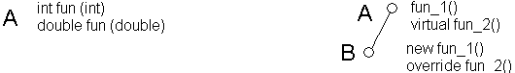

public class A // Virtual_NonVirtual
{ protected int a;

public A ( int aa ) { a = aa; }

public void funct_1()
{ Console.WriteLine("Funct_1 from A a = {0}", a);
}
virtual public void funct_2()
{ Console.WriteLine("Funct_2 from A a = {0}", a);
}
}
public class B : A
{ private int b;

public B (int aa, int bb) : base (aa) { b = bb; }

new public void funct_1()
{ Console.WriteLine("Funct_1 from B a = {0} b= {1}", a, b);
}
override public void funct_2()
{ Console.WriteLine("Funct_2 from B a = {0} b= {1}", a, b);
}
}
public class Test
{ static void Main()
{ A myA = new A ( 1 ), AA ;
B myB = new B ( 2, 3 );

myA.funct_1(); // Funct_1 from A a = 1
myA.funct_2(); // Funct_2 from A a = 1
myB.funct_1(); // Funct_1 from B a = 2 b = 3
myB.funct_2(); // Funct_2 from B a = 2 b = 3

//// if ( ### )
//// AA = myA;
//// else
//// AA = myB;
//// AA.funct_1();
//// AA.funct_2();

AA = myA;
AA.funct_1(); // Funct_1 from A a = 1
AA.funct_2(); // Funct_2 from A a = 1

AA = myB;
AA.funct_1(); // Funct_1 from A a = 2
AA.funct_2(); // Funct_2 from B a = 2 b = 3
}
}
}

AA.funct_1(); Early binding
AA.funct_2(); Late binding

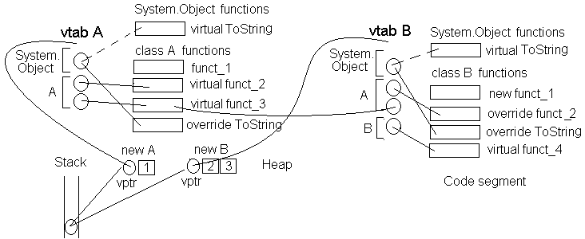

yptr Virtual Pointer
ytab Virtual Table

